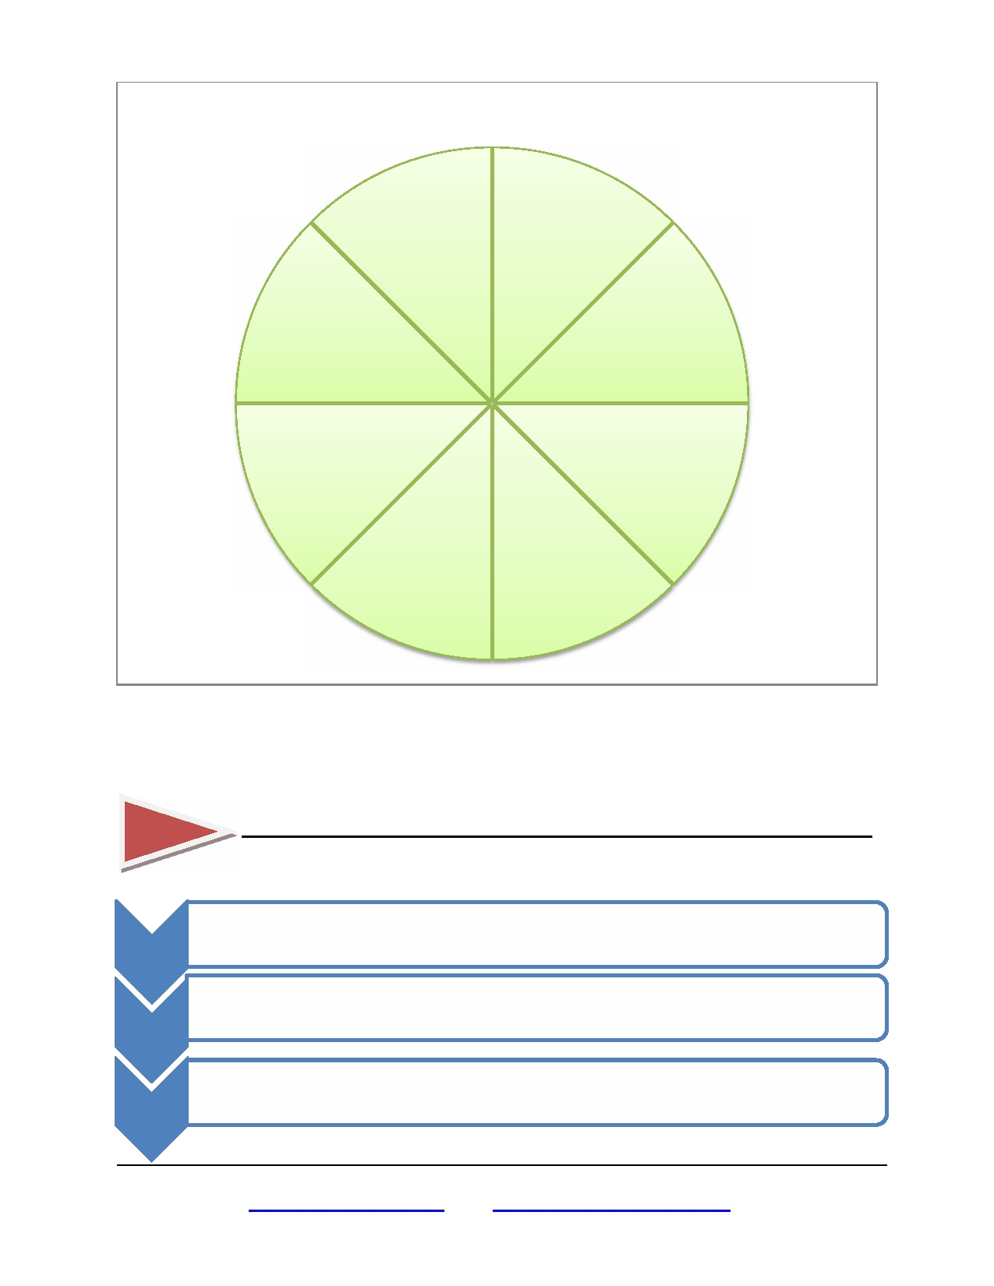
Wheel of Life

Career/ Vocation

Family and Friends

Physical
Environment Significant Other/
Romance

Personal /
Spiritual Growth
Fun & Recreation

Money

Health

The eight sections in the Wheel of Life represent Balance. Seeing the center of the wheel as 0 and the outer edges as 10, rank your level of satisfaction with each life area by drawing a straight or curved line to create a new outer edge. The new perimeter represents the wheel of your life. If this
were a real wheel, how bumpy would the ride be?

AN AREA OF MY LIFE TO IMPROVE IS_________________________________________

SOMEONE WHO CAN SUPPORT ME DOING THIS IS ______________________________

• ACTION:

1

2

3
• WHEN:
• ACTION:
• WHEN:

• ACTION:
• WHEN:

THE FARINA GROUP | PO BOX 2609 | RED OAK TX | 75154 | P. 919.696.0184 | E. office@samfarina.com | www.samfarina.com

